Step-by-Step Curriculum Mapping
- Gather list of courses in program, syllabi (and faculty, whenever possible) for those courses, and copy of program SLOs
- Open DMC Mapping Template (Excel document)
  - Click on the tab at the bottom for PSLO Map (if not the active sheet)
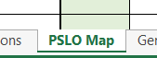

- Enter program SLOs (PSLOs) across top of sheet where indicated (SLO 1:, SLO 2:, etc.)
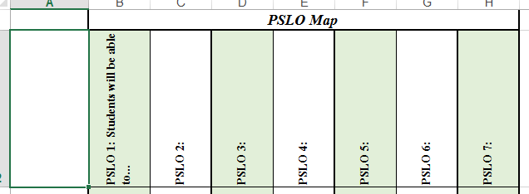

- Enter program courses down left side of page
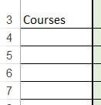
- For EACH course, determine which PSLOs are part of that class, and enter I (Introduced), R (Reinforced), or M (Mastered) in the intersecting cell for the PSLO and the course. For those courses in which the PSLO is assessed, also enter A (Assessed)
- Analyze the map to ensure that each PSLO has an I, R, M and A, and that each course supports at least one of the PSLOs.
  - If a PSLO is not introduced, reinforced, and mastered (and then assessed) within the program, then work with program faculty to determine which courses should accomplish those functions and make the necessary course changes.
  - If a course is blank (does not support any of the PSLOs), the work with program faculty to determine which PSLOs should be addressed in that course and at what level and make the necessary course changes.
Gen Ed Map:
Click on Gen Ed Map tab at bottom, then follow steps 4 and 5 above.
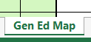
NOTE: The Gen Ed Map does NOT have to indicate I, R, M, and A for EACH competency.

